Experiment: 7 Analog Beamforming Analysis Using MATLAB

Objectives
1. To analyze the beamforming gain achieved by varying the number of antenna elements in an analog beamforming system using MATLAB.
2. To compare the beam width of an antenna array for different beamforming configurations using MATLAB.
3. To analyze the main lobe direction by steering the antenna array beam to different angles using MATLAB.

Objective – 1
Analyze Beamforming Gain (dB)
Generate beamforming gain values for different antenna array sizes using MATLAB. Compare
how increasing the number of antenna elements improves the beamforming gain and enhances
signal strength.

MATLAB Code:
clc;
clear;
close all;
antennas = [2 4 8 16 32]; % Number of Antenna Elements
gain = 10*log10(antennas); % Beamforming Gain (dB)
figure
bar(antennas, gain)
grid on

xlabel('Number of Antenna Elements')
ylabel('Beamforming Gain (dB)')
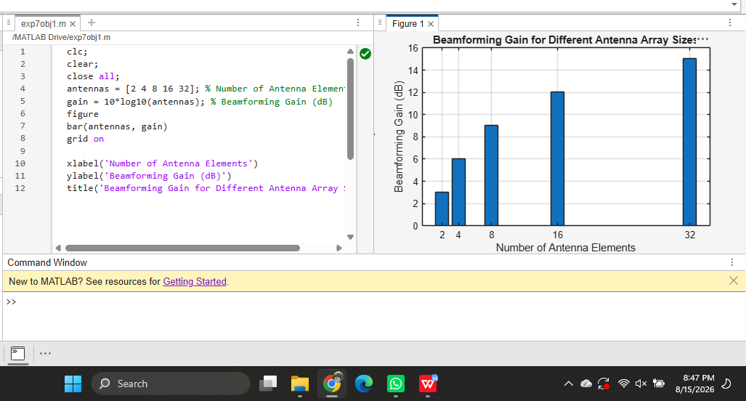
title('Beamforming Gain for Different Antenna Array Sizes')
Objective – 2
Compare Beam Width (Degrees)
Analyze the beam width corresponding to different antenna array sizes using MATLAB. Observe how increasing the number of antenna elements results in a narrower beam, thereby improving spatial resolution.

MATLAB Code:
clc;
clear;
close all;
antennas = [2 4 8 16 32]; % Number of Antenna Elements
beamwidth = [90 45 22.5 11.25 5.625]; % Beam Width (degrees)
figure
plot(antennas, beamwidth,'o-','LineWidth',2)
grid on
xlabel('Number of Antenna Elements')
ylabel('Beam Width (Degrees)')
title('Beam Width for Different Antenna Array Sizes')
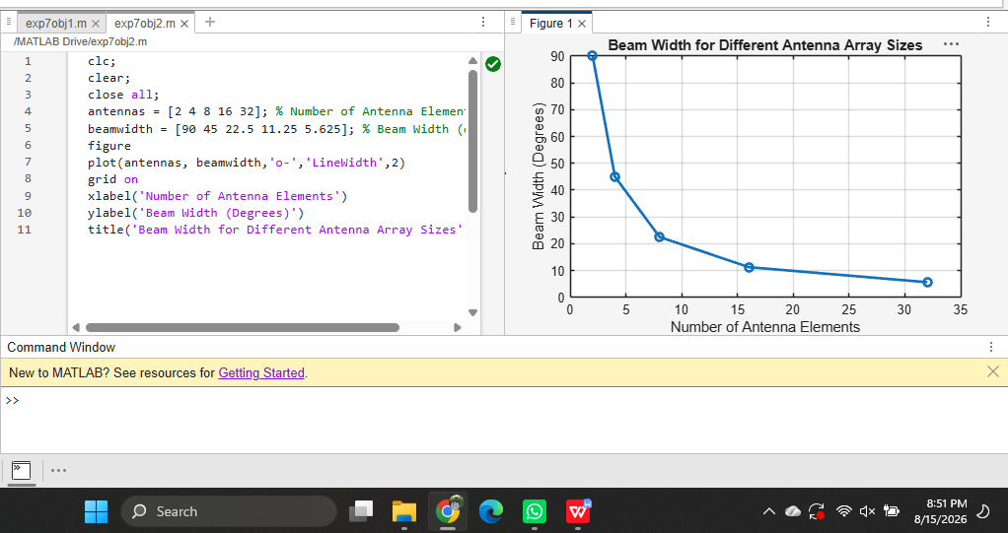

Objective – 3

Analyze Main Lobe Direction (Degrees)
Simulate beam steering by varying the steering angle of the antenna array using MATLAB. Observe the change in the main lobe direction and understand how analog beamforming directs energy toward the intended user.

MATLAB Code:
clc;
clear;
close all;
theta = [-60 -30 0 30 60]; % Main Lobe Direction (degrees)
gain = [1 1 1 1 1]; % Constant normalized gain
figure
polarplot(deg2rad(theta), gain, 'o', 'LineWidth', 2)
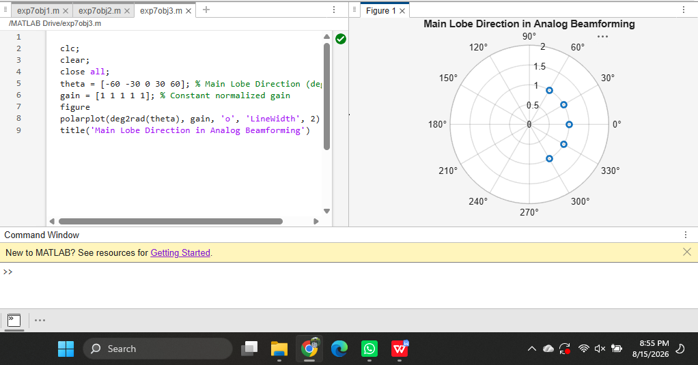
title('Main Lobe Direction in Analog Beamforming')

